Construction of Longest Common Subsequence
1) Construct L[m+1][n+1] using the steps discussed in previous post.
2) The value L[m][n] contains length of LCS. Create a character array lcs[] of length equal to the length of lcs plus 1 (one extra to store \0).
2) Traverse the 2D array starting from L[m][n]. Do following for every cell L[i][j]
…..a) If characters (in X and Y) corresponding to L[i][j] are same (Or X[i-1] == Y[j-1]), then include this character as part of LCS.
…..b) Else compare values of L[i-1][j] and L[i][j-1] and go in direction of greater value.
The following table (taken from Wiki) shows steps (highlighted) followed by the above algorithm.

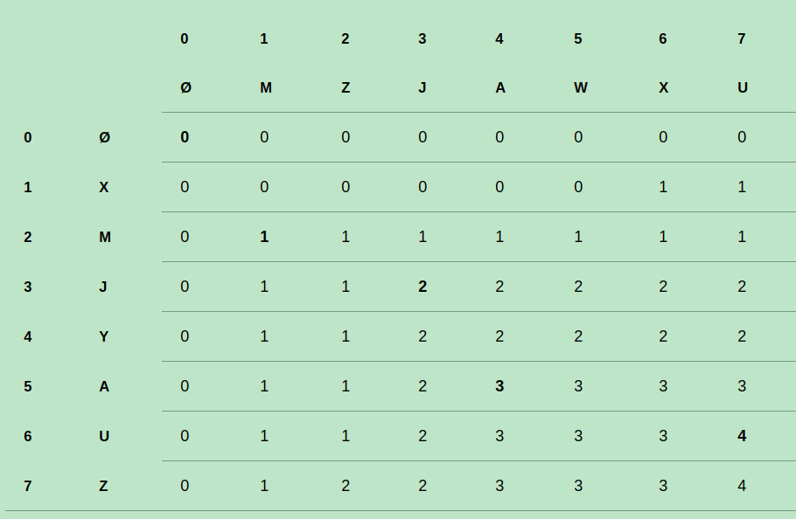
注意，
dp[i][j]的dp[i-1][j]==dp[i][j-1]==dp[i-1][j-1]==dp[i][j]-1输出这个值，str[i] or str[j]
否则，如果dp[i-1][j]==dp[i][j] 那么i--；
如果 dp[i][j-1]==dp[i][j]那么j--;
当dp[i][j]的值变为0的时候，就输出完毕了，直接结束

